What’s the temperature?
Big Ed has just arrived on a new planet and he’s measuring the temperature of his new environment.

In the program below, you will see that there is a variable named ‘temperature’.
Each time the variable changes value, Big Ed will say it’s new value. Your task is to write down what Big Ed says each time you see the following:

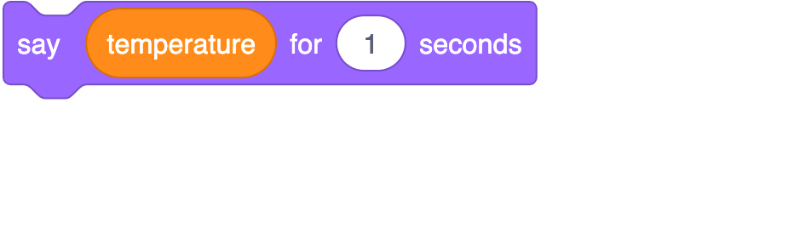

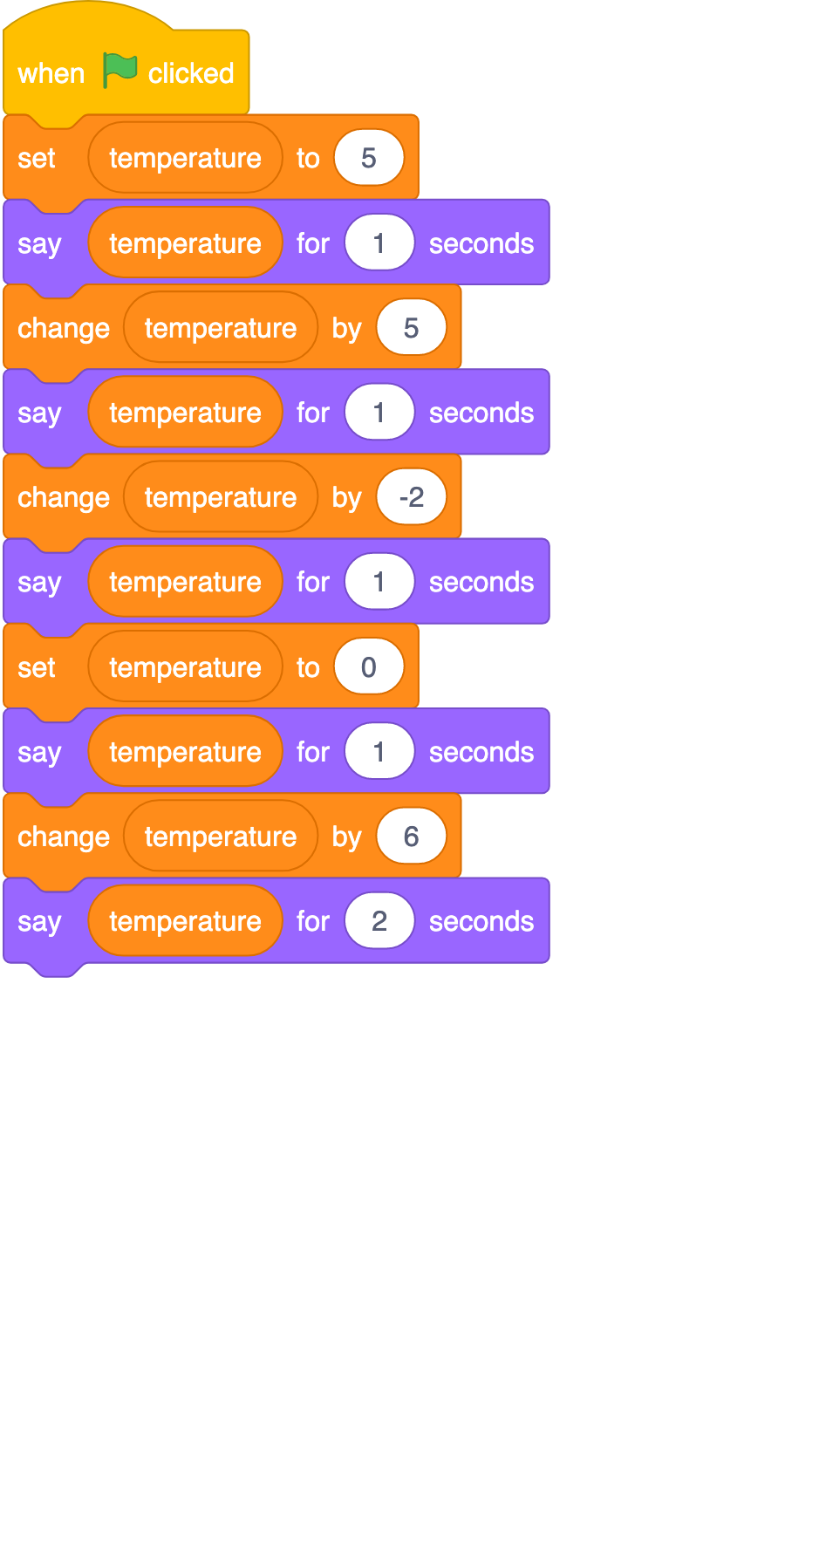 | Write in the space below the value of temperature when you see the Say block
Resources are updated regularly — the latest version is available at: ncce.io/tcc. This resource is licensed under the Open Government Licence, version 3. For more information on this licence, see ncce.io/ogl.

